Atchison Active Long Duration SMA 31 March 2025

|  |  |  |  |  |  |
| --- | --- | --- | --- | --- | --- |
|  | 3 Months | 6 Months | 1 Year | 2 Years (p.a.) | Since Inception |
| AtchisonLongDuration | **1.27** | **0.17** | **2.64** | **2.26** | **3.98** |
| Peer Group | 1.24 | 0.99 | 3.6 | 3.43 | 4.46 |
| Inflation | 0.0 | 0.0 | 2.25 | 2.82 | 3.13 |
| Outperformance vs Peers | 0.02 | -0.82 | -0.96 | -1.17 | -0.48 |
| Outperformance vs Inflation | 1.27 | 0.17 | 0.39 | -0.56 | 0.85 |

Inception Date: 31 December 2022

Investment Objective

Outperform the FE AMI Fixed Int – Global Bond Peer Index, after fees, over rolling five-year periods.

Strategy Overview

The Atchison Active Long Duration Portfolio offers a bespoke solution as part of your defensive bond asset allocation. Investing across a broad spectrum of bonds and structures, the portfolio combines fixed income assets with duration exceeding three years to deliver a diversified fixed income solution.

|  |  |
| --- | --- |
| Key Details |  |
| Strategy Category | Long Duration |
| Strategy Provider | Atchison |
| Benchmark | FE AMI Fixed Int – Global Bond Peer Index |
| Inception Date | 31 December 2022 |
| Investment Horizon | 5 Years |
| Risk Level (SRM) | Medium |
| Min Investment | 5k |
| Product Fee | Platform Specific - Refer to PDS |
| Underlying MER | 0.30% |
| Underlying Perf Fees | 0.00% |

Strategy Performance

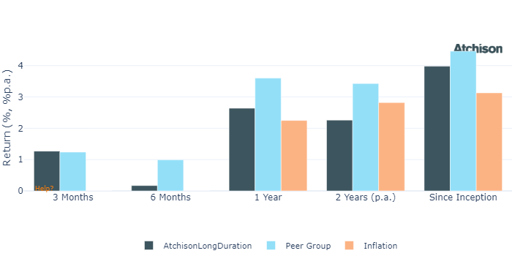

Cumulative Performance Since Inception

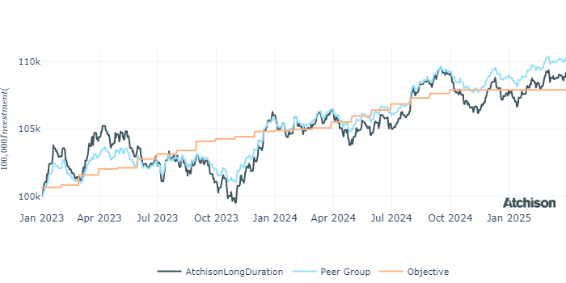

Portfolio Allocations

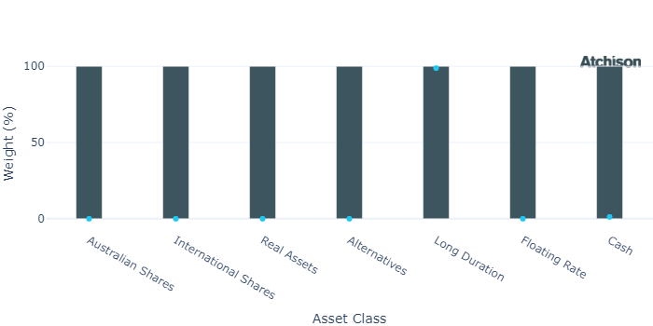

Portfolio Construction

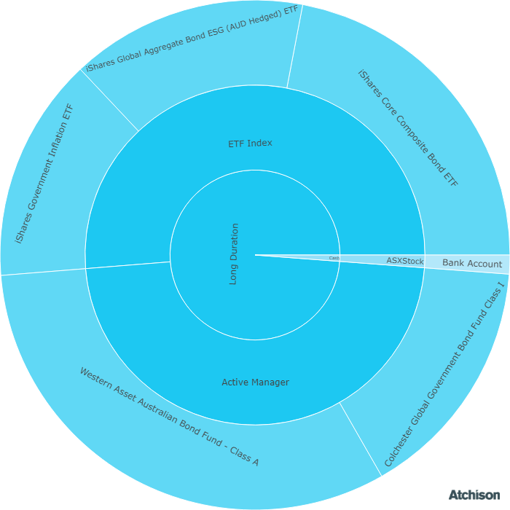

Correlations

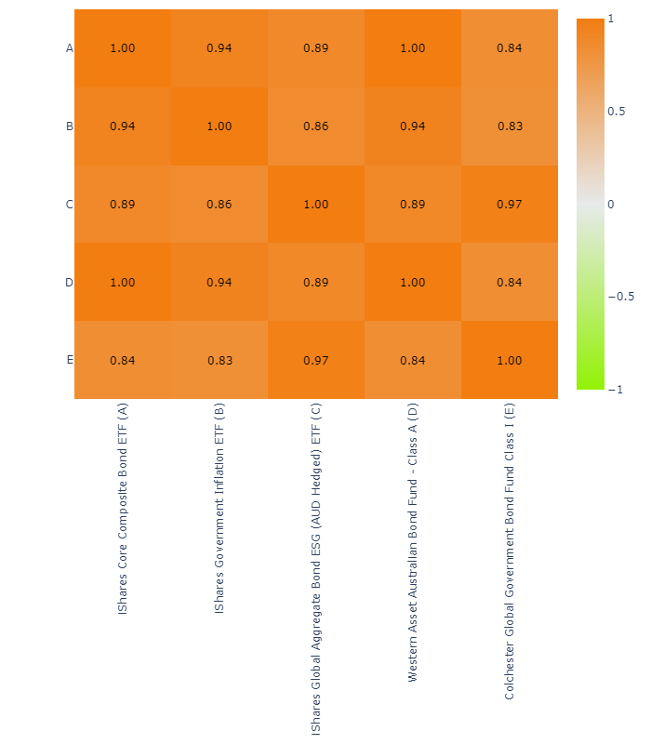

Underlying Manager Performance

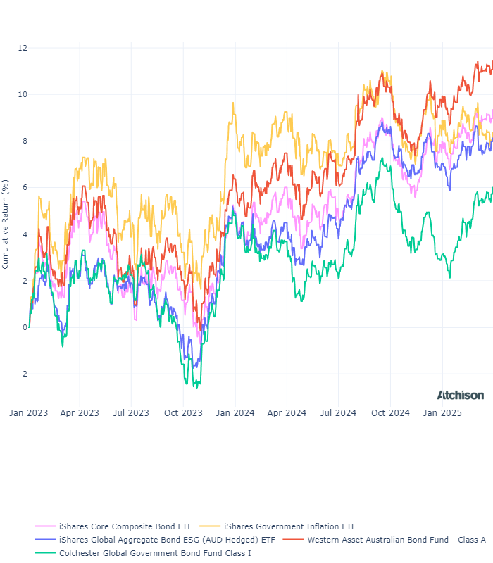

|  |  |  |  |
| --- | --- | --- | --- |
| **Strategy** | **1 Year** | **2 Years (p.a.)** | **Since Inception** |
| BR Aus Bond | 3.15 | 2.25 | 1.16 |
| BR CPI Bond | -0.8 | 0.73 | 1.04 |
| BR Globa Agg ESG | 3.48 | 2.85 | 1.01 |
| WA Aus Bond | 3.71 | 2.95 | 1.41 |
| Colchester Gov Bond | 2.25 | 1.73 | 0.75 |
| **BM: Duration** | **3.33** | **2.58** | **1.1** |
| Cash | 4.6 | 4.42 | 1.23 |

Market Update

Australian share market took a lead from the US share market and dropped -3.3% in March on fears of a global trade war and intensifying fears of recession. Recent events highlight the challenges our economy faces, namely our reliance on exports to China. Australia sends around 35% of its iron ore to China.  
  
The Trump administration scheduled to announce at the beginning of April a raft of new reciprocal tariffs on trading partners worldwide. The size and extent of those tariffs remained unknown, and that kind of uncertainty did zero to boost investor sentiment.  
  
Markets interpreted the expected new tariffs as the catalyst to crimp global economic growth and potentially reignite inflation, leading to fewer than originally expected interest rate cuts over CY 2025.  
  
More recent views (post March 2025) are that after the dust settles, effective tariffs on US imports could settle around 15% next year, compared to figures currently pushed out by the Trump administration, 15% doesn’t seem that high, but still the highest in almost a century.  
  
Global market fell -5.0% in the month March led by the US S&P 500 Index down -6.2%. The tech-heavy NASDAQ benchmark was down -8.2% for the month. European markets fared slightly better, benefiting from ongoing rotation from investors seeking alternatives to the US. The STOXX Europe 600 benchmark was down -3.7%.  
  
The Reserve Bank of Australia (RBA) has previously noted that the enduring strength in employment was a potential roadblock to further rate cuts. In the US, the Federal Reserve maintained rates at the current level with minimal changes to the dot-plot projections. The US dollar continued to weaken against major currencies.  
  
The monthly CPI indicator rose +2.4% in the 12 months to February. Largest contributors to the annual movement were Food and non-alcoholic beverages (+3.1%), Alcohol and tobacco (+6.7%), and Housing (+1.8%).  
Bond yields rose slightly in March, the Australian 10-year bond rate was up 13 bps to 4.42% bps. Whilst US 10-year bond edged up 1 bps to 4.21% but was higher mid-month.  
Gold continued to hit record highs with the yellow metal topping US$3000 for the first time and closing about US$3100.  
Additional commentary is provided in our monthly market update.

Fine Print

Important Notice: This document is published by TAG Asset Consulting Group Pty Ltd, trading as Atchison Consultants, ABN 58 097 703 047, AFSL 230 846. Atchison Consultants distributes its investment solutions via platform and dealer groups (financial advisory groups).

Warning: Please be advised that past performance is not indicative of future performance. The returns discussed herein are based on model asset allocations and are for illustrative purposes only. Actual returns may differ due to variations in fees, timing of model change implementation, and the need to substitute individual holdings where reliable data was not available from our data providers. Any insights or recommendations provided in this document are intended for general advice purposes only and are based on our opinion of the investment merits of the financial products discussed, independent of the financial circumstances of any individual. Before proceeding with any investment based on the information provided, recipients must assess its suitability to their financial situation and consider seeking advice from an independent financial advisor.

Disclaimer: While care is taken to ensure the accuracy and completeness of the information presented herein, no warranties or representations are made as to its reliability. The content provided is derived from publicly available sources, or external data providers, which have not been independently verified by Atchison Consultants. Atchison Consultants, along with its directors, officers, employees, and agents, expressly disclaims any liability for errors, inaccuracies, or omissions in this document, as well as for any loss or damage that may arise from reliance on its contents. Readers are cautioned to verify all information independently before taking any actions based on this report.